

Functional Strength Training for the Older Adult
Geriatric ECHO 4/14/26
Amanda Wilson, PT, DPT




Objectives
- Identify signs and symptoms to indicate referral for individualized strength training.
- Explain the benefits of strength training for older adults.
- Understand how to reinforce behavior change for initiation of strength training.

Case Presentation
Robert Thompson is a 72-year-old retired high school teacher who was referred to physical therapy by his primary care provider for participation in a strengthening program due to gradually worsening weakness and decreased functional mobility. He reports that over the past 3–5 years he has noticed increasing difficulty rising from low chairs, fatigue when walking longer than 10 minutes, and avoidance of stairs because his legs feel weak.
Robert states he would like to begin exercising again but is unsure how to do so safely and is concerned about injuring himself if he starts lifting weights. His past medical history includes controlled hypertension, type 2 diabetes mellitus, and mild bilateral knee osteoarthritis. He lives with his spouse in a single-level home, is independent with activities of daily living, and drives independently.

Case Questions
- Is Robert’s presentation “normal” for his age?
- What signs and symptoms triggered the referral?
- Why would strength training be beneficial for Robert?
  - Bonus: What would be the best way for him to do the strength training?
- What are the barriers to Robert engaging in strengthening?
- How would you facilitate behavior change?

Age-related Musculoskeletal Changes: Decreased
- Muscle Fibers
  - Especially type II (fast twitch)
- Muscle Strength, Power, Endurance
- Muscle Mass (Sarcopenia)
- Elasticity of Tissues
- Vertebral Disc Height
- Postural Alignment
- Bone Mineral Density (Osteoporosis)
  - Increased osteoclastic activity

Age-related Musculoskeletal Changes: Increased
- Muscle fat
- Muscle connective tissue

Factors Leading to Age Related MSK changes
  - Apoptosis – programmed cellular death -> atrophy
  - Oxidative stress/inflammation -> free radicals
  - Neuromuscular changes -> muscle wasting
    - Decreased motor units/conduction/excitability
  - Tendon changes -> injury & less repair
  - Osseous structures decline
  - Osteoporosis – metabolic disorder after 50 yrs
    - Decrease calcium/Vit D accelerates problem
    - OA -> major cause of pain/dysfunction

Effects of Age on Maximal Strength¹
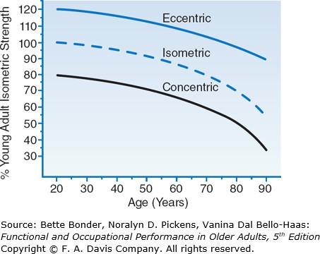

Strength Changes²2
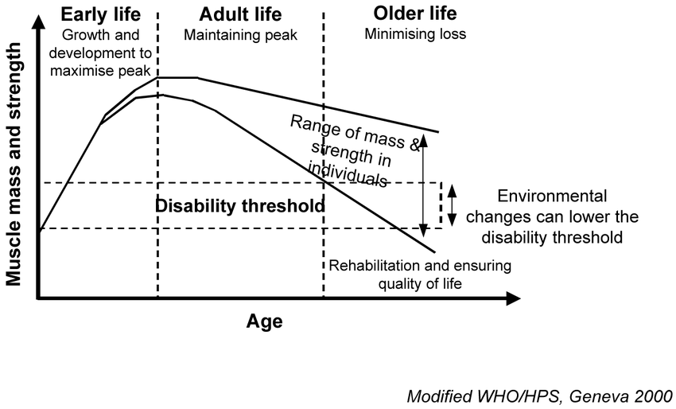

Case question #1
    - Is Robert’s presentation “normal” for his age?

Case Presentation
Robert Thompson is a 72-year-old retired high school teacher who was referred to physical therapy by his primary care provider for participation in a strengthening program due to gradually worsening weakness and decreased functional mobility. He reports that over the past 3–5 years he has noticed increasing difficulty rising from low chairs, fatigue when walking longer than 10 minutes, and avoidance of stairs because his legs feel weak.
Robert states he would like to begin exercising again but is unsure how to do so safely and is concerned about injuring himself if he starts lifting weights. His past medical history includes controlled hypertension, type 2 diabetes mellitus, and mild bilateral knee osteoarthritis. He lives with his spouse in a single-level home, is independent with activities of daily living, and drives independently.

Power Changes
- Muscle power (type II mm fibers) = ability to generate force rapidly
- Strong predictor of functional status in the older adult
- Power examples: jumps, punches, kicks, tackles, throws
- Power declines at more than 2x the rate strength does
- 2x per week concurrent (aerobic and resistance) exercise as effective as 3x per week in previously trained “elderly” males
- Heart failure can decrease the muscular power of the lower limbs in the elderly
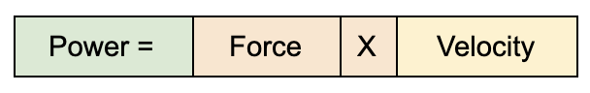

Sarcopenia



Sarcopenia: Defined
- Syndrome characterized by progressive and generalized loss of skeletal muscle mass and strength with a risk of adverse outcomes such as physical disability, poor quality of life, and death.
- Skeletal muscle mass >2 standard deviations below the healthy young adult mean
- Does NOT equal disuse atrophy

Causes of Sarcopenia
- Physical inactivity
- Loss of alpha-motor neuron input to the muscle
- Decline in testosterone (age-related)
- Decline in growth hormone
- Protein deficiency
Which of these is/are the most modifiable?? Screening tool: SARC-F

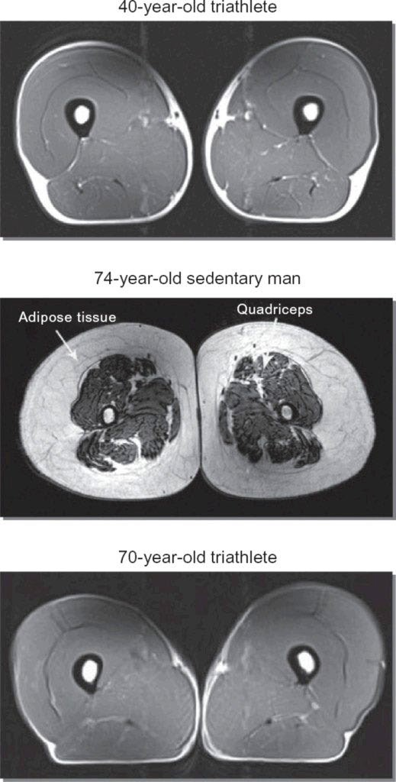
Cross Section- Sarcopenia

Case question #2
  - What signs and symptoms triggered the referral?

Case Presentation
Robert Thompson is a 72-year-old retired high school teacher who was referred to physical therapy by his primary care provider for participation in a strengthening program due to gradually worsening weakness and decreased functional mobility. He reports that over the past 3–5 years he has noticed increasing difficulty rising from low chairs, fatigue when walking longer than 10 minutes, and avoidance of stairs because his legs feel weak.
Robert states he would like to begin exercising again but is unsure how to do so safely and is concerned about injuring himself if he starts lifting weights. His past medical history includes controlled hypertension, type 2 diabetes mellitus, and mild bilateral knee osteoarthritis. He lives with his spouse in a single-level home, is independent with activities of daily living, and drives independently.

ACSM3 FITT for Older Adult

 | Aerobic | Resistance | Flexibility | Balance
Frequency | >5 d/wk for mod int.  >3 d/wk for vig int. 3-5 d/wk for combo | >2 d/wk | >2 d/wk | 2-3d/wk-daily
Intensity | Moderate RPE 12-13/20 (3-4/10) progress to vigorous RPE 14-17/20 (>5/10) Borg scale (modified scale) | Progressive weight training: light 40-50% (1-RM) intensity progress to moderate to vig (60-80% 1 RM) **Last 2 reps should be challenging | Stretch to point of tightness and/or mild discomfort | Progressive difficulty: WBOS-NBOS, dynamic movements, postural muscle groups, reduced sensory input.
Time | 150 min/wk moderate OR 75 min /wk of vigorous. Any combinations, can be accumulated over the day. | Progressive wt training: 8-10 ex major mm groups; >1set of 10-15 reps beginning progress to 1-3 sets of 8-12 reps  Power training: 3 sets of 6-10 reps (high velocity) 30-60% of 1-RM. Or Cluster sets (less than 4 reps) | 30-60 sec
Type | Any type, consider pt’s tolerance: walking, aquatic, etc. | Progressive or power wt. training or weight bearing calisthenics, stair climbing, other | Static stretching, no ballistic. | Tai chi, dancing, team sports, Nordic walking, active computer gaming.

1-RM Assessment (ACSM)3

Number of completed reps | Percentage of I-RM
1 | 100
2 | 95
3 | 93
4 | 90
5 | 87
6 | 85
7 | 85
8 | 80
9 | 77
10 | 75
11 | 70
12 | 67
15 | 65

Strengthening for the older adult

(ACSM pg. 228&233 & Bonder pg 203)3,1

- Initial workload should be light in the beginning (40-50% 1 RM)

  - Especially for individuals with lower function and significant deconditioning.

- Individualized progression, highly tailored

  - Widest range of fitness abilities
  - Closely monitor MSK/chronic conditions, and functional limitations
  - Apply the overload principle

- Older adults should gradually exceed the minimum recommendations.

Strengthening for the older adult

(ACSM pg. 228&233 & Bonder pg 203)3,1

- Muscular strengthening is more important with increasing age.

  - Cluster set: less than 4 reps per set maintains better power output

- Use a variety of muscle contractions

  - Isometric, concentric, and eccentric
  - Through controlled & pain-free ranges

- Recommended supervision of machines & free weights for strengthening.

Strengthening for the older adult

(ACSM pg. 228&233 & Bonder pg 203)3,1

  - Should include multi-components

    - Aerobics, muscular strength, power, endurance, flexibility, and balance
    - With at least 2 or more components reduced falls risk by 32-40%

  - Include a warm-up & cool-down, especially for those with known CVD.

Strengthening for the older adult

(ACSM pg. 228&233 & Bonder pg 203)3,1

- Include behavioral strategies to improve participation

  - ie: social support, self-efficacy, and the ability to make healthy choices.

- Provide regular feedback, positive reinforcement and other strategies to enhance adherence.
- Monitor skin for signs of heat stress

- Monitor BP, respirations, and pulse rate

- Monitor intensity: RPE or talk test

Case Question #3
- Why would strength training be beneficial for Robert?
  - Bonus: What would be the best way for him to do the strength training?

Case Presentation
Robert Thompson is a 72-year-old retired high school teacher who was referred to physical therapy by his primary care provider for participation in a strengthening program due to gradually worsening weakness and decreased functional mobility. He reports that over the past 3–5 years he has noticed increasing difficulty rising from low chairs, fatigue when walking longer than 10 minutes, and avoidance of stairs because his legs feel weak.
Robert states he would like to begin exercising again but is unsure how to do so safely and is concerned about injuring himself if he starts lifting weights. His past medical history includes controlled hypertension, type 2 diabetes mellitus, and mild bilateral knee osteoarthritis. He lives with his spouse in a single-level home, is independent with activities of daily living, and drives independently.

Examples of strength training
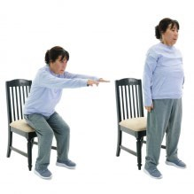
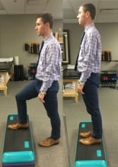
Initiate at: 40-50% 1-RM
Power components, add speed with safety

Older Adults exercise stats:

- Only 16% age 65-74 engage in recommended aerobic and muscle strengthening (ACSM, pg222)3
- Only 8.7% age >75 years old, strength train⁴

Barriers to exercise
Location of activity6
  - Transportation difficulties Life space mobility
  - functional, environmental, and social factors
Safety, fear, health concerns, pain, fatigue, lack of social support5
Readiness to change

Motivators to exercise5
- Age longevity
- Health status
- Being able to live independently

Case Question #4 & 5
- What are the barriers to Robert engaging in strengthening?
- How would you facilitate behavior change?

Case Presentation
Robert Thompson is a 72-year-old retired high school teacher who was referred to physical therapy by his primary care provider for participation in a strengthening program due to gradually worsening weakness and decreased functional mobility. He reports that over the past 3–5 years he has noticed increasing difficulty rising from low chairs, fatigue when walking longer than 10 minutes, and avoidance of stairs because his legs feel weak.
Robert states he would like to begin exercising again but is unsure how to do so safely and is concerned about injuring himself if he starts lifting weights. His past medical history includes controlled hypertension, type 2 diabetes mellitus, and mild bilateral knee osteoarthritis. He lives with his spouse in a single-level home, is independent with activities of daily living, and drives independently.

References
- Bonder B, Pickens N, Bello-Haas V. Functional and Occupational Performance in Older Adults, 5th Edition | F.A. Davis PT Collection | McGraw Hill Medical. 5th ed. F.A. Davis Company; 2024. Accessed December 29, 2025. https://fadavispt.mhmedical.com/book.aspx?bookid=3522

- WHO Health Systems Governance and Financing. The world health report 2000. 2000. Accessed December 29, 2025. https://www.who.int/publications/i/item/924156198X

- Ozemek C, Bonikowske A, Christle J, Gallo P. Chapter 6 Exercise Prescription for Healthy Populations With Special Considerations. In: ACSM’s Guidelines for Exercise Testing and Prescription. 12th ed. Wolters Kluwer; 2025: 222-233

- Fragala, M. S., Cadore, E. L., Dorgo, S., Izquierdo, M., Kraemer, W. J., Peterson, M. D., & Ryan, E. D. (2019). Resistance Training for Older Adults: Position Statement From the National Strength and Conditioning Association. Journal of Strength and Conditioning Research, 33(8), 2019–2052. https://doi.org/10.1519/JSC.0000000000003230

- Burton E, Farrier K, Lewin G, et al. (2017) Motivators and barriers for older people participating in resistance training: A systematic review. J Aging Phys Act 25: 311–324. https://doi.org/10.1123/japa.2015-0289.

- Maresova, P., Krejcar, O., Maskuriy, R. et al. (2023) Challenges and opportunity in mobility among older adults – key determinant identification. BMC Geriatr 23, 447. https://doi.org/10.1186/s12877-023-04106-7

